Indiana Historical Society  Job Description  July 2018 | 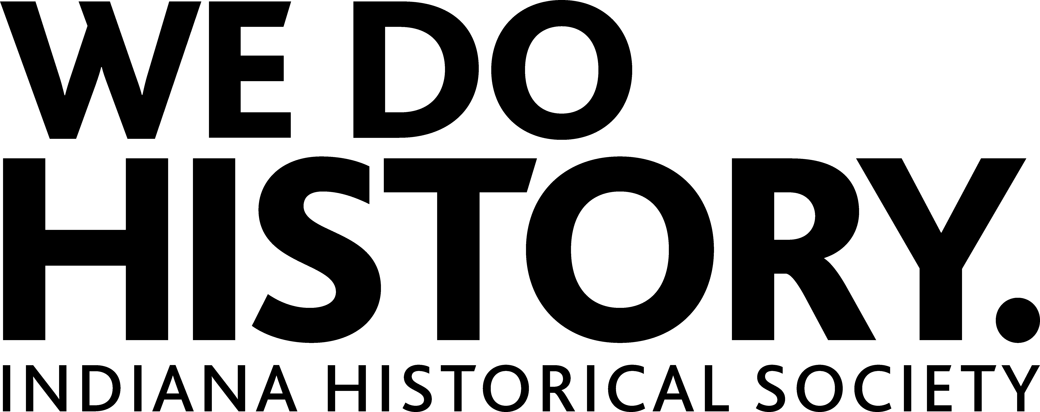
Job Title: | Specialist, Learning & National History Day
Department: | Education & Community Engagement
Reporting Relationship: | Coordinator, Education & National History Day
Employees Supervised: | N/A
Full/part time: | Part Time, no more than 25 hours/week
FLSA Status & pay grade: | Non-Exempt; $10/hour

POSITION PURPOSE:
Facilitates the administration and execution of the NHDI program on behalf of the Indiana Historical Society; works with school districts across the state and assists in the development of new educational services and resources. Works cooperatively with Indianapolis Public School system and other external stakeholders to advance educational programming on behalf of IHS. Works cooperatively with a variety of internal and external stakeholders advancing educational programming on behalf of IHS with an emphasis on building relationships with the Indianapolis Public School system. The specialist also coordinates education messages through various social media networks.

ESSENTIAL FUNCTIONS:
National History Day in Indiana
- Support planning, research, delivery, and evaluation of all NHDI contests and programs that take place on-site at IHS, and offsite at locations across the state.
- Plan and manage delivery of NHDI content through digital platforms including but not limited to Twitter, Facebook, Instagram, Snapchat, and the IHS blog.
- Serve as project consultant and judge for various NHDI school visits and contests.
- Assist with merchandise inventory and sales as well as seeking out new revenue and support opportunities.
- Regularly visit IPS schools and provide support and resources for their participation in NHDI.
- Develop and maintain effective relationships with IPS teachers, administrators, curriculum coaches, etc.
- Collaborate with Learning Team to develop and deliver large-scale events as necessary.
Education Administration
- Compile and report on NHDI social media reach.
- Assist with compiling and reporting on NHDI key performance indicators.
- Assist with copy writing for the annual educator resource guide, delivery of consistent digital communication to teachers, and finding ways to increase student visitation.
- Assist with maintenance of department’s database of education contacts.

General Administration & Department Support
- Administer general department organization such as timekeeping, meetings, etc.
- Perform other duties as assigned.
ESSENTIAL KNOWLEDGE, SKILLS, & ABILITIES:
- Understanding of elementary and secondary teaching of history and social studies. Stay current on best practices and trends in informal education.
- Understanding of generally accepted museum education concepts, strategies, ethics, and standards.
- Commitment to telling IHS stories in a meaningful and effective way.
- Excellent communication skills, both verbal and written, which includes a significant number of public presentations.
- Ability to manage multiple tasks simultaneously.
- Complex problem solving skills in order to develop and implement solutions.
- Proficient skills related to utilizing social media in an effective manner.
- Excellent computer skills; proficient with Microsoft Office suite as well as basic office equipment.
- Experience with event and conference planning a plus.

PHYSICAL REQUIREMENTS:
Work is performed in a typical office environment with some work outdoors.
Physical Movement – Stooping, Climbing, Bending, Kneeling, Reaching and Crouching in order to reach & pick up items. Must be able to walk and/or stand for long periods of time.
Strength – Ability to lift & carry items weighing up to 35 pounds
Wrist & Visual Stamina – Ability to type and focus on a computer screen for prolonged periods of time
(Incumbent must be able to meet physical requirements with or without reasonable accommodations. Reasonability of requested accommodation is to be determined by IHS on a case-by-case basis, in accordance with the ADA.)

QUALIFICATIONS:
MINIMUM: Work towards degree in communications, marketing, history, education, museum studies, or closely related field. 1 year experience in formal or informal education. Experience working with children and educators. Experience with research, development, and implementation of programs in any learning setting. Valid driver’s license, reliable transportation, and willingness to travel, including some overnight trips. Schedule part time up to 25 hours per week is primarily between Monday and Friday, but maintain flexibility to work occasional evenings, weekends, and special events – especially during the busy NHD season (Spring). Experience with customer service and sales. Familiarity with Square sales platform.
PREFERRED: Bachelor’s degree in communications, marketing, history, education, museum studies, or closely related field .

Part-time
This position is limited to 25 hours/week. Pay is $10/hour. No group health or dental benefits are provided for this position. Other benefits include free parking, staff discounts in the Basile History Market and the Stardust Café, and reciprocal benefits at other cultural institutions in Indianapolis.

Applications
Please send a cover letter and resume to: Human Resources, Indiana Historical Society, 450 West Ohio Street, Indianapolis, IN 46202, hr@indianahistory.org or Fax: 317/233.0857. Applications will be accepted until the position is filled.

The Indiana Historical Society is an equal opportunity employer.
www.indianahistory.org

